Task 1)

select first_name, last_name, email, phone_number, hire_date, department_id from employees

-> order by hire_date desc;

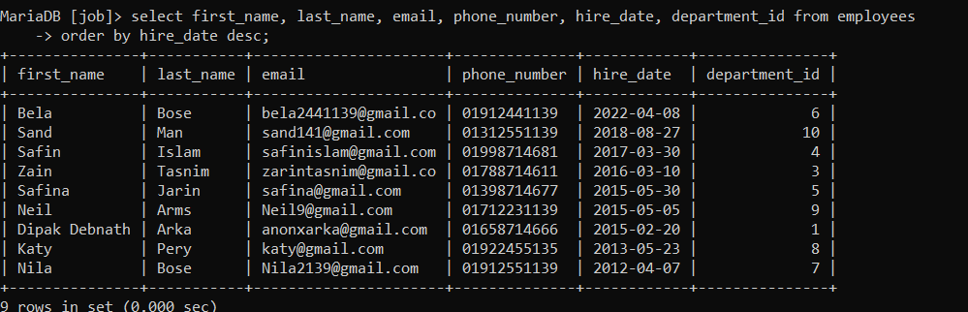

Task 2) select first_name, last_name, employee_id,phone_number,salary, department_id from employees where salary in ( select min(salary) from employees group by department_id );

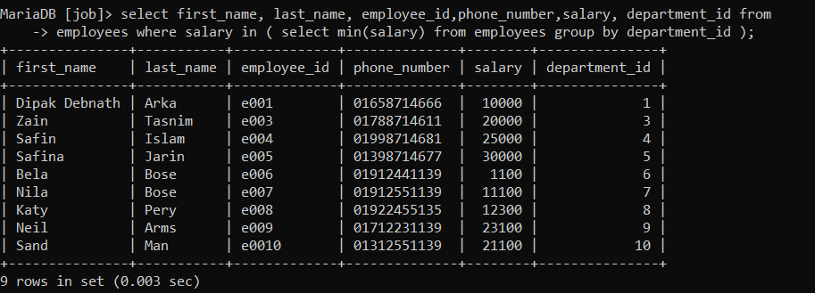

Task 3)

select first_name,last_name,employee_id,commission_pct,department_id from employees where department_id=7 and commission_pct < (select min(commission_pct) from employees where department_id=5);



Task 4) select department_id,count(*) from employees where salary < 30000 and salary in (select max(salary) from employees group by department_id) group by department_id;

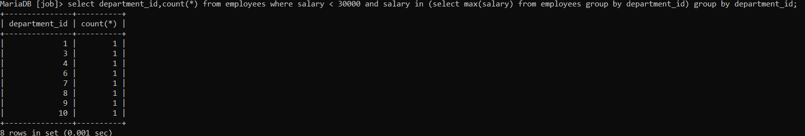

Task 5)

select department_id,job_id,commission_pct from employees where commission_pct < job_id group by department_id;

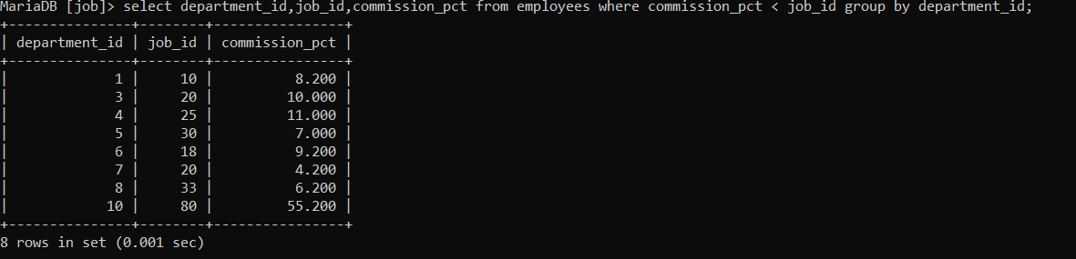

Task 6) select manager_id from employees where salary >3500 and salary in (select min(salary) from employees group by manager_id);

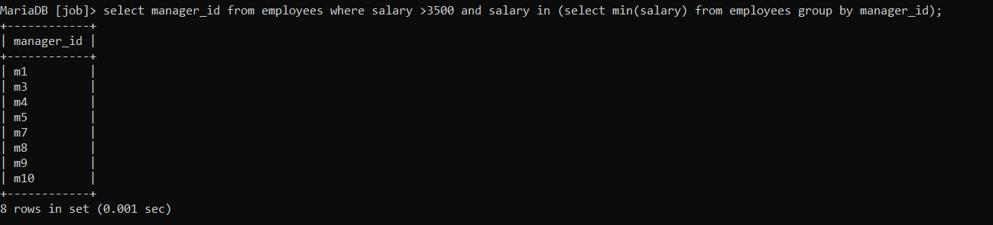

Task 7)

select first_name, last_name, employee_id, email, salary, department_id, commission_pct from employees where commission_pct in (select min(commission_pct) from employees group by manager_id);

